THE

KING OF BLUNDER

Personalized Manual for Proper learnings

BUILD GOOD CHARACTER

CREATE TRUSTED VIRTUE

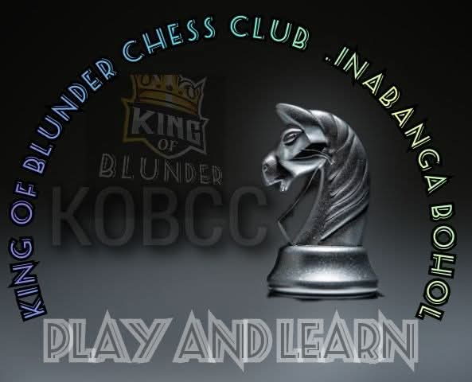TRUST GOD ABOVE ALL

NIMZOSWISTCH – LONDON – CATALAN

MODERN – NIMZO INDIAN – LARSEN

BENONI – PONZIANI – CAROKHAN

OWEN – PETROV – VAN’T KRUIJS

ENGLISH – HORWITZ

Origin:

At first their are 3 chess player's who played chess almost every night back way August 2023 namely Arch angel Himaya Lumer Pague and Gil Magno Both player's have a vision of Reviving CHESS game in Inabanga, until they decided to find some player's na naay same vision sa ilaha.

Archangel introduce Ryan Melleza to the team from Cambitoon and Lumer pague reach out his younger Brother Mercelu Pague and Regine Remulta to be a part of small movement which have a goal of developing chess players. So mao to September 03 2023 King of blunder Chess club was born which is dapat unta na(64 square wood pusher chess club ang name).

Vision

To become an Eye Opener to everyone that Chess is a sport where Filipinos can excel and not just only side games.

Mission

To develop young prospects within Inabanga and in nearby municipalities by Doing clinics and mini tournaments.

Goal

To Successfully Produce chess Master and Revive chess form being forgotten in INABANGA .

TABLE OF CONTENT

* ***Board***
* ***Pieces Name and Value***
* ***Notation***
* ***Chess Openings Principles***
* ***Chess Openings***
* ***Middle game Principles***
* ***Middle Game Tactics***
* ***End Game Principles***
* ***Mastery of end Game***
* ***Puzzles***

**BOARD**

In chess game we all know that it has 64 on the board 32 for white 32 for white and each Square has it’s corresponded name’s

See Diagram below

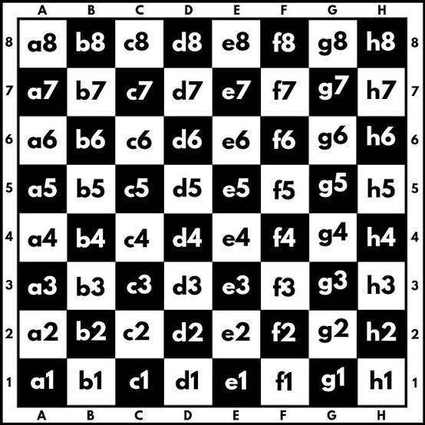

The 1 to 8 number are called RANK while the a to h called FILE

As we continue we should Memorize and carefully Understand the Chess Board itself .

**CHESS PIECES**

In CHESS We have 6 different characters namely as

* King 👑 - ♾️
* Queen 👑 - 9
* Rook - 5
* Bishop - 3
* Knight - 3
* Pawn - 1

**KING**

The game moves around into this piece the king , if this piece has been capture the game is over . Means the main Objective of the games was to protect the KING out of being Capture means being trap with a check which Called as CHECKMATE.

SEE THE DIAGRAM below for the kings movement and image

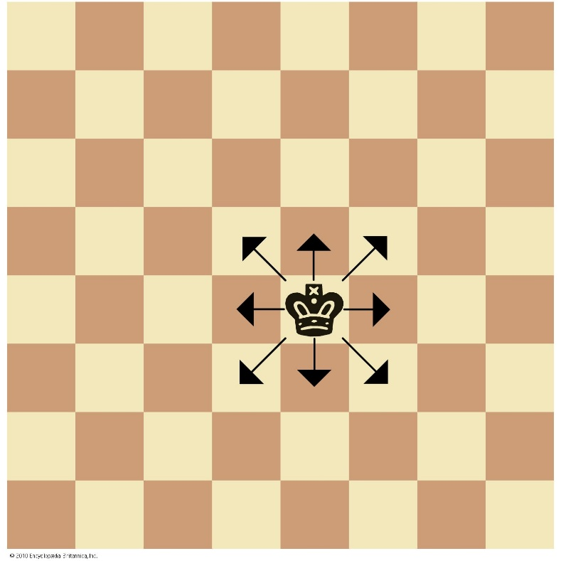

**QUEEN**

the queen is the most powerful piece, combining the movement of a rook and bishop. It can move any number of unblocked squares vertically, horizontally, or diagonally. Each player starts with one queen, positioned next to the king, and it holds the highest point value in the game.

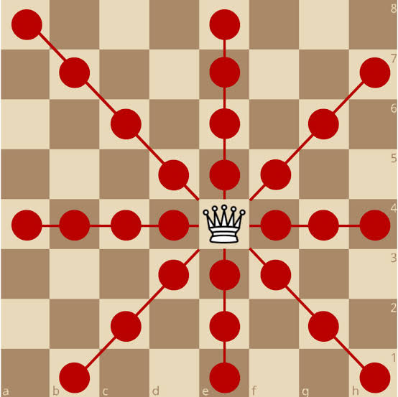See the Diagram below

ROOK

The rook is a powerful piece that moves any number of unoccupied squares horizontally or vertically, but not diagonally. Each player starts with two rooks, positioned in the corners of the board

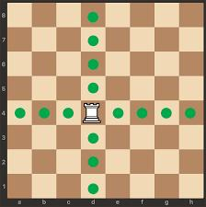See’s Diagram Below

**BISHOP**

the bishop is a piece that moves and captures diagonally across the board. Each player starts with two bishops, one on a light square and one on a dark square, and they can never switch colors. Bishops are considered minor pieces, worth three points, and are effective at controlling open diagonals but can become trapped by pawns.

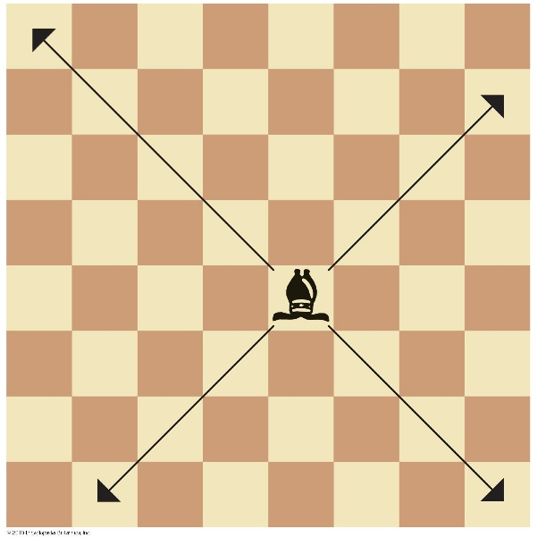See’s Diagram below

**KNIGHT**

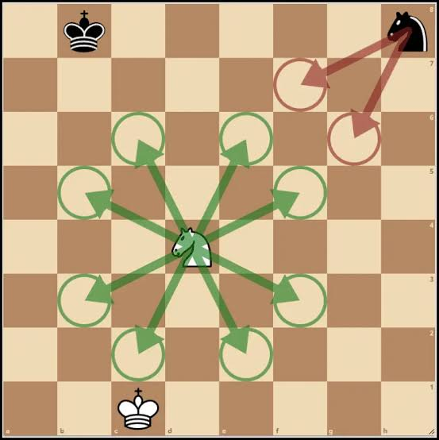The knight is a chess piece shaped like a horse’s head and neck, valued at three points, and is the only piece that can “jump” over other pieces to reach its destination. It moves in a unique L-shaped pattern: two squares in one direction (horizontally or vertically) and then one square perpendicularly.

**PAWN**

In chess, the pawn is the weakest piece but most numerous, starting with eight for each side. Pawns move one square straight forward, or two on their first move, and capture by moving one square diagonally forward. They cannot move backward, can be blocked, and if a pawn reaches the opponent's back rank, it is promoted to a more powerful piece, such as a queen.

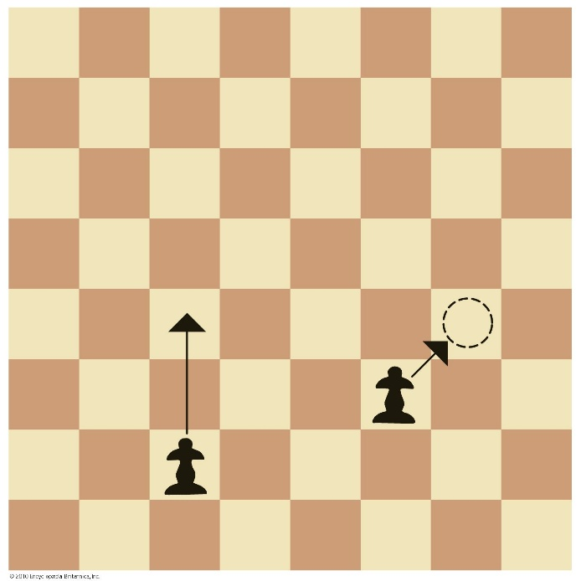See’s Diagram Below

***CHESS NOTATION***

* **KING ( K )**
* **QUEEN ( Q )**
* **ROOK ( R )**
* **BISHOP ( B )**
* **PAWN - Name determine on its square file**
* **CHECK ( + )**
* **CHECKMATE (# )**
* **KING SIDE CASTLE ( O-O )**
* **QUEEN SIDE CASTLE ( O-O-O )**
* **CAPTURED ( X )**
* **PROMOTION ( = )**
* **GOOD MOVE ( ! )**
* **BRILLIANT ( !! )**
* ***MISTAKES* ( ? )**
* **BLUNDER ( ?? )**
* **INACCURATE ( !?)**

**CHESS PRINCIPLES**

1. Control the Center
2. Develop Minor pieces
3. Pawn structure
4. Protecting each pieces
5. King Safety
6. Avoid moving pieces twice in not necessary
7. Better square development
8. Find opponents weakness
9. Control center file such as C to F file

***EXPLAINED SOME OF OPENING PRINCIPLES***

1. Control the Center

-Controlling the center with pawns and pieces gives you:

- More mobility and flexibility

- Better development opportunities

- Increased attacking and defending capabilities

*2. Piece Development*

Developing your pieces:

- Moves them from starting positions

- Puts them in active positions

- Supports controlling the center

3. Pawn Structure*

Good pawn structure:

- Supports piece development

- Controls key squares

- Limits opponent mobility

4. Protection of Pieces*

Protecting pieces:

- Safeguards material advantage

- Preserves attacking and defending capabilities

5. Attack Weak Points*

Attacking weak points:

- Targets opponent's vulnerable pieces or squares

- Gains strategic advantage

Some common weak points include:

- Undefended pawns

- Pieces in vulnerable positions

- Weak squares

The rest of the principles are understandable itself accordingly on how it was written. Understand and apply those principles mention above into you game and make it a habit for you to able to improve you chess game.

Chess Principles are the foundation of knowledge, a basic aspects which helps you to build critical approach in a critical situations.

**PERSONALIZED CHESS OPENINGS**

**LONDON SYSTEM**

The London System is a versatile opening that can be employed against various Black responses. Here are some key aspects:

- *Flexibility*: The London System allows White to delay committing to a specific pawn structure, making it adaptable to different Black setups.

- *Solidity*: The system is known for its solid and positional nature, aiming to control key central squares and develop pieces harmoniously.

- *Simplicity*: The London System is considered relatively easy to learn and understand, making it accessible to players of various skill levels.

Some common ideas and strategies in the London System include:

- *Controlling the center*: White aims to control key central squares with pawns and pieces.

- *Developing pieces*: White develops pieces harmoniously, often with a focus on the bishop pair.

- *Creating pawn chains*: White may create pawn chains to restrict Black’s mobility and control key squares.

MAIN LINE

d4 d5

Bf4 g6

e3 Bg7

Nf3 e6

Bd3 c5

c3

Accelerated

D4 d5

Bf4 g6

e3 Nf6

Nd2 Bg7

c3 Be2

h4

JOBAVA SYSTEM

d4 d5

Nc3 Nf6

Bf4 a3

e3 b5

a3

**CATALAN OPENING**

The Catalan Opening

1. d4 d5

2. c4 Nf6

3. g3

It’s known for its solid, positional style and flexibility. White aims to control the center and develop the rest of their pieces harmoniously.

- Controlling the center with pawns on d4 and c4

- Fianchetto the bishop on g2 to put pressure on Black’s position

- Developing other pieces harmoniously

black possible responds

- Challenging White’s central control

- Developing your pieces actively

- Counter-attacking on the queenside

possible outcome

1.d4 d5

2.c4 e6

3.g3 Nf6

4.Bg2 Be7

5.Nf3 O-O

6.O-O

White aims for long-term control and slow buildup, while Black focuses on equalizing. Some key ideas for Black include playing …dxc4 to challenge White’s central control or …c5 to counter-attack.

Continue the control in the middle with your proper approach and line understand.

**CLOSE CATALAN**

startwith

d4 d5 ( Queen Gambit line)

c5 e6 ( Queen Gambit declined)

g3 Nf6

Bg2 Be7

Nf3 O- O

O-O dxc4

Qc2 c6

Qxc4

**OPEN CATALAN**

d4 d5

c4 e6

g3 Nf6

Nf3 dxc4

Bg2 Bb4+

Bd2 a5

Qc1 c5

dxc5 Bxc5

O-O O-O

Ne5 Nc6

Nxc6 bxc6

Qxc4 Qb6

NIMZOSWISTCH DEFENCE ( Personal Favorite Opening)

1. Nimzowitsch Defense (1. E4 Nc6):

2. d4:

This leads to several possibilities, including the Scandinavian Defense (2…d5) or the Kennedy Variation (2…e5).

2. Nf3:

This move invites Black to reveal their intentions and can transpose to other openings.

2. Nc3:

This is another common response, leading to different lines depending on Black’s subsequent moves.

3. Nimzowitsch Variation in Sicilian Defense (1. E4 c5 2. Nf3 Nc6 3. D4 cxd4 4. Nxd4 d5):

This variation is characterized by Black’s early …d5 push, aiming to challenge White’s central control.

It can lead to complex tactical and positional battles.

4. Other Variations:

The Nimzowitsch System in the French Defense (1. E4 e6 2. D4 d5 3. E5) involves White’s early pawn advance in the center.

Nimzowitsch’s hypermodern approach is also reflected in openings like the Nimzo-Indian Defense (1. D4 Nf6 2. C4 e6 3. Nc3 Bb4) and the Grunfeld Defense (1. D4 Nf6 2. C4 g6 3. Nc3 d5).

General Ideas and Considerations:

Nimzowitsch’s ideas emphasized hyper modernism, where control of the center is achieved indirectly through piece play rather than direct pawn occupation.

The Nimzowitsch Defense, in particular, is known for its complexity and dynamic possibilities.

These openings are often used as surprise weapons or to steer the game away from well-trodden theoretical paths.

Black’s early …Nc6 in the Nimzowitsch Defense is a flexible move, allowing for various transpositions and strategic plans

***MIDDLE GAME***

It is often considered the most complex part of the game, where strategy and tactics are crucial for creating or exploiting weaknesses and aiming for checkmate or a decisive advantage. Key middle game principles include controlling the center, activating pieces, identifying and attacking opponent weaknesses, and developing specific plans based on the opening played.

Remember the 4 Basic ***PRINCIPLES*** of the middle game

1. Find Checkmate
2. Find the Check
3. Look for a opponent hanging piece
4. Maneuver and make your pieces more active and involved to a variety of execution.

**Advance Principles**

Complexity and Strategy:

The middle game is often the most challenging and decisive phase, requiring a deep understanding of positional play and specific game plans.

Piece Activity:

Centralized pieces that control many squares are very active and valuable, increasing tactical opportunities.

Pawn Structure:

Pawns play a vital role in opening the position to allow for attacks or creating weaknesses in the opponent’s camp.

Threats and Plans:

Players create threats (short-term or long-term) and develop strategic plans based on the unique characteristics of the opening and the resulting pawn structure.

Weaknesses:

Identifying and exploiting weaknesses in the opponent’s position, such as weak pawns or a poorly defended king, is a core goal.

Material vs. Activity:

While material (the value of pieces) is important, piece activity and control of key squares are often just as crucial for a successful attack or defense.

Some strategic principles include:

1. *Open Lines*: Open lines for your pieces to attack or move through.

2. *Forking*: Attack multiple opponent pieces simultaneously.

3. *Pinning*: Attack an opponent piece, forcing them to move a more valuable piece.

**Tactical Concepts**

1. *Discovered Attacks*: Moving a piece, revealing a attack from another piece.

2. *Overloaded Pieces*: Pieces responsible for multiple tasks, vulnerable to attack.

3. *Back Rank Mate*: Checkmating opponent's king on its starting rank.

**Personalized Favorite Tactics**

**Windmill**

a powerful tactic, also called a "seesaw," where a player forces an opponent's king into a series of squares, allowing the attacker to deliver repeated checks and capture multiple pieces. Typically, a windmill is executed with a bishop and a rook, using discovered and direct checks to create an unstoppable series of moves that can win a large amount of material.

How the Windmill Works

1. Position the Pieces:

You need a bishop and a rook (or other pieces like a bishop and knight) lined up to attack an exposed king.

2. Force the King onto a Diagonal:

You maneuver the pieces to force the opponent's king onto the same diagonal as the attacking bishop.

3. Initiate the Checks:

The rook moves to deliver a direct check on the king.

This forces the king to move, usually to a different square.

The rook then returns to its original position, delivering a discovered check from the bishop.

4. Repeat and Capture:

The king is forced to move back to its previous spot to escape the newly discovered check.

The rook then moves to deliver another check, often capturing a piece along the way.

This cycle of moving the rook, delivering a check, and capturing more pieces is repeated.

5. Result:

This tactic can result in the capture of many pieces, a significant advantage, or even a perpetual check and a draw.

Key Aspects of a Windmill

[Discovered Check](https://www.google.com/search?client=ms-android-xiaomi-terr1-rso2&sca_esv=0341e61adf0435df&sxsrf=AE3TifN_FgB2hIyYyQwFnAbluewKoD4ASQ%3A1756732649749&q=Discovered+Check&sa=X&sqi=2&ved=2ahUKEwja1baM07ePAxV6SPUHHRrDIswQxccNegUI_gEQAQ&mstk=AUtExfCtym9MqlwdxkPIyeBz0DppSqgqxPFP6e4t7eqI9FJwoUyPlkaB8QrYW83ZMpo1bjdtEqCTc0kQJMrxZhaw1xW4008KqC7a5ilDIMWlKkcweaPJv1fQRxtv0XgteF04hZcU7syuiJb8l84TzHUZm0udtPH9g3GM0HJGchTZDIj20Jp-Y2cgGl0usjdVAgeQTUJauhj324m8WMTP3dSbUYQxV5aaIoArr_8bNS_LbsygQj-DCltoPrfnpWRFmN8xHAFX53G06e-oSk-I8mVG2M7S&csui=3):

The core of the tactic, where moving the rook reveals a check from the bishop.

Repetition:

The king is forced to move back and forth, often between two squares, allowing the attacker to continue the sequence.

Material Gain:

The primary goal is to win large amounts of material from the opponent.

Preparation:

It often requires sacrificing a piece (sometimes a queen) to set up the position or lure the king into the necessary configuration.

Piece Configuration:

While usually a bishop and rook, it can also involve other combinations of pieces.

**X – RAY**

is a tactic where a piece indirectly attacks an enemy piece or square through another piece, or defends a friendly piece through an enemy piece. This hidden line of influence is revealed when the intervening piece moves, potentially creating a skewer, winning a piece, or setting up a checkmate. The concept relies on "seeing through" obstructions to a target beyond.

How an X-ray Works in Practice

Perceive the “X-ray”: You notice a line of influence from your piece through an opponent’s piece to a target behind it.

Remove the Blocker: You move the intervening piece, often with a threat of your own, forcing it to move and reveal the X-ray.

Exploit the Revelation: The move of the blocker exposes the target to your piece.

Example Scenario

Imagine a white queen on d1 and a black king on e1. After the king moves, the queen on d1 can target a white rook on d5, which is defended by a black queen on d8. Black’s queen on d8 is X-raying the black rook on d5, making the rook an exposed target.